Project 1 Final Report – BIOS 6624
1 Introduction
The data for this project was collected by the Multicenter AIDS Cohort Study, an ongoing prospective cohort study of HIV-1 infection in homosexual and bisexual men in 4 major cities in the United States. Highly active antiretroviral treatment (HAART) is the current gold standard for treating HIV-infected individuals. The study collects both laboratory and quality of life measures of subjects at baseline and then annually after starting HAART. The primary measures of interest included viral load, CD4+ T cell counts, physical quality of life scores and mental quality of life scores.
Previous studies have provided limited evidence in both in vitro and animal settings that suggest hard drug use may inhibit the immune system and increase HIV replication. However, these findings have not been reproduced in human studies thus far. If hard drugs do indeed impair treatment response in people living with HIV, treatment protocols may need to be modified for patients with a history of hard drug use. With this information, the investigator aimed to assess the difference in treatment response 2 years after starting HAART between subjects who reported using hard drugs at baseline and those who did not. The investigator was also interested in exploring whether adherence accounted for some of the difference in treatment response between the two hard drug use groups. To address these research questions, we assessed whether there was a significant coefficient associated with hard drug use and whether incorporating adherence significantly affects that coefficient.
2 Methods
2.1 Data Cleaning
The initial dataset contained 3,935 individual observations from 715 unique participants. With
the defined focus of the analysis, annual visits recorded at baseline and year two were retained. Participants missing either of these two visits were removed. This produced a total of 1,012 observations from 506 unique participants. An additional 13 participants were excluded due to biologically implausible recorded BMIs, less than 6.7 kg/m² or greater than 250 kg/m². Another 17 were removed due to failure to report income. Finally, 30 participants were excluded for missing any of the outcomes of interest at either baseline or year two. After applying all exclusion criteria, the final analytic sample consisted of 446 unique participants.
The necessity of transforming the four outcomes of interest was assessed to avoid potential model assumption violations. Viral load was log10 transformed due to substantial right skewness. The remaining three outcomes exhibited mild skewness and were retained in their original scale. This decision was verified through residual diagnostic plots from the fitted models. Categorical covariates were condensed after consulting investigator to avoid small sample sizes.
2.2 Statistical Analysis
The impact of baseline hard drug use on treatment response was evaluated for each of the four outcomes of interest using both frequentist and Bayesian linear regression frameworks. Those outcomes were viral load, CD4+ T cell count, physical quality of life, and mental quality of life. Each model included the year 2 outcome as the response variable, with baseline hard drug use as the primary predictor of interest. All models were adjusted for the following baseline covariates: age, BMI, race, education, smoking status, income, and the corresponding baseline outcome measurement.
For the frequentist approach, ordinary least squares linear regression was used. Statistical significance was evaluated using a threshold of p < 0.05.
For the Bayesian approach, models were fit using Stan via CmdStanR. Weakly informative priors
were specified as Normal(0, 100) for all regression coefficients and Half-Normal(0, 100) for the error standard deviation. Each model was run with 4 chains, 25,000 sampling iterations, and 5,000 warmup iterations. Convergence was assessed using the Gelman-Rubin statistic (R-hat < 1.01), effective sample size, and visual inspection of trace plots. Model fit was evaluated using leave-one-out cross-validation, LOO-CV, and the widely applicable information criterion, WAIC.
To assess whether treatment adherence at year 2 could account for some of the observed relationship between baseline hard drug use and treatment outcomes, eight additional models were fit following the same structure described above, with adherence added as a covariate.
All data preparation and statistical analyses were conducted using R version 4.4.1.
3 Results
Of the 446 participants included in the analysis, 410 reported no hard drug use at baseline while 36 reported hard drug use. A summary of baseline characteristics for all participants is provided in Table 1. The two groups were broadly similar in age, BMI, and all four clinical outcomes at baseline. Participants who reported no hard drug use were more likely to identify as white/non-Hispanic (65% vs. 53%), hold a college degree (45% vs. 28%), be a non-smoker (65% vs. 25%), and report a higher income.
3.1 Effect Hard Drug Use on Treatment Response
The results of both the frequentist and Bayesian approaches are presented in Table 2. Across all four outcomes, the two approaches yielded virtually identical results, with matching estimates for viral load and physical quality of life, and nearly identical estimates for CD4+ T cell count and mental quality of life. The 95% confidence intervals and highest posterior density intervals were slightly different in width but led to the same conclusions for all outcomes.

Table 1. Summary Statistics of Participants at Baseline Visit.
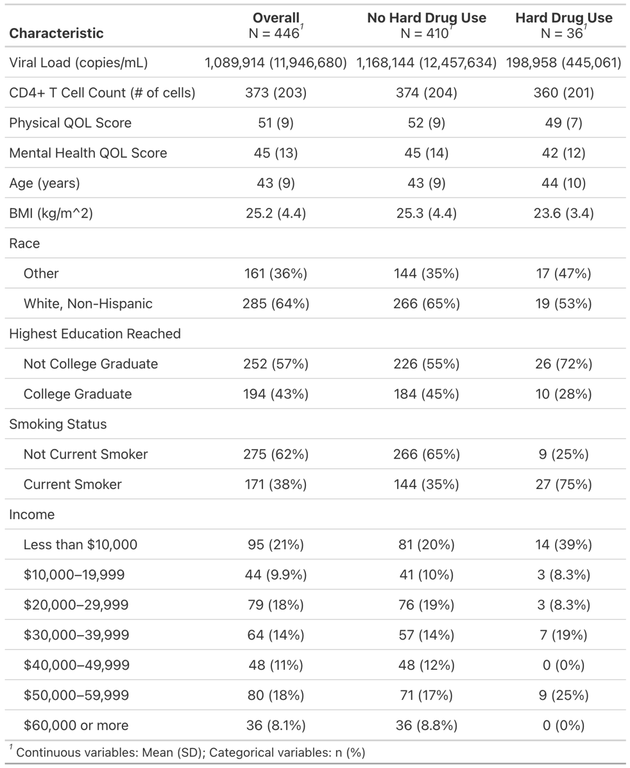
Baseline hard drug use was associated with a statistically significant reduction in CD4+ T cell count at year two (β = -159.02, 95% CI: (-221, -97.04), p < 0.001), with the Bayesian approach yielding a consistent estimate (Posterior Mean = -143.47, 95% HPDI: (-203, -85.22)). Physical quality of life also showed a significant negative association with baseline hard drug use (β = -3.28, 95% CI: (-6.01, -0.55), p = 0.019), again consistent with the Bayesian result (Posterior Mean = -3.28, 95% HPDI: (-6.04, -0.57)). No meaningful associations were observed for viral load (β = -0.20, 95% CI: (-0.59, 0.20), p = 0.325) or mental quality of life (β = 0.06, 95% CI: (-3.5, 3.62), p = 0.974), with both intervals including zero.
Table 2. Effect of Hard Drug Use on Outcomes in Frequentist and Bayesian Approaches.
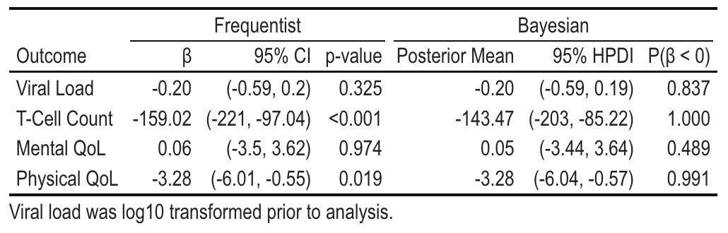
3.2 Influence of Adherence on the Hard Drug Use Effect
Results from models adjusting for adherence are presented in Table 3. As illustrated, the inclusion of adherence had minimal impact on the estimated effect of hard drug use across all four outcomes. For CD4+ T cell count, the coefficient shifted slightly from -159.02 to -166.00 in the frequentist model, with the Bayesian estimate similarly moving from -143.47 to -148.64, and both remaining highly significant (p < 0.001, P(β < 0) = 1.000). For physical quality of life, the estimate changed modestly from -3.28 to -3.47 (p = 0.013), with the Bayesian result consistent (Posterior Mean = -3.46, P(β < 0) = 0.993). Viral load and mental quality of life remained non-significant in both models with and without adherence.
Table 3. Effect of Hard Drug Use on Outcomes With and Without Adjusting for Adherence
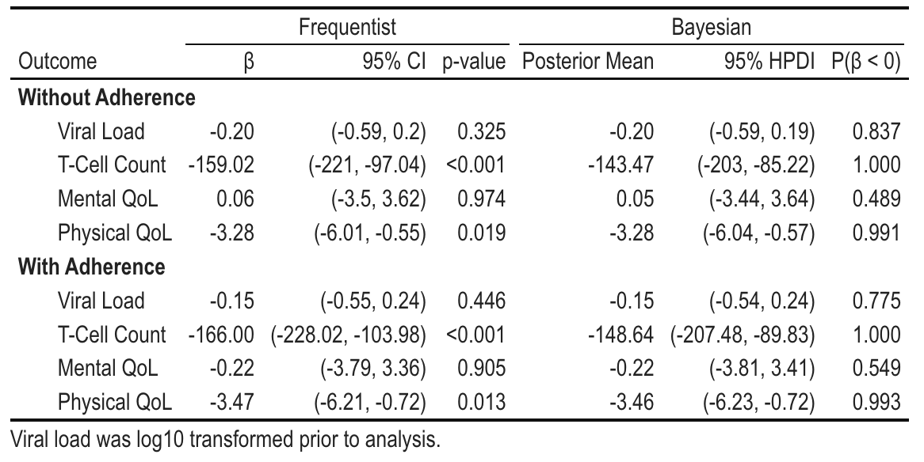
Overall, the addition of adherence did not meaningfully affect the effect of hard drug use on any outcome, suggesting adherence does not substantially account for the observed differences in treatment response between groups.
4 Discussion
This study examined the impact of baseline hard drug use on treatment response two years after initiating HAART using both frequentist and Bayesian linear regression frameworks. Baseline hard drug use was associated with statistically significant reductions in CD4+ T cell count (β = -159.02, p < 0.001) and physical quality of life (β = -3.28, p = 0.019), while no significant associations were observed for viral load or mental quality of life. [Insert clinical meaningfulness commentary here]. The absence of a significant association with viral load may reflect the effectiveness of HAART in suppressing viral replication regardless of hard drug use status.
The addition of treatment adherence did not meaningfully attenuate the effect of hard drug use on any outcome, with coefficients remaining largely unchanged. This suggests the relationship between hard drug use and treatment outcomes operates through mechanisms beyond adherence alone, potentially through direct pharmacological or immunological pathways.
The consistency between the frequentist and Bayesian approaches across all outcomes strengthens confidence in these findings, with near-identical point estimates and high posterior probabilities for the two significant outcomes. Several limitations should be noted, including the small sample of hard drug users (n = 36), assessment of hard drug use only at baseline, and the observational study design which precludes causal inference.
5 Reproducible Research
All data files and analysis code relevant to this project and final report are available at: https://github.com/mmschina/BIOS6624. All code can be found within the folder titled Project1/Code/, where there are separate scripts for data cleaning and analysis. The original dataset can be found under Project1/Data/hiv_6624_final.csv on the local drive, specifically: /Users/Madelynn/Documents/Spring 2026 Courses/Advanced Statistical Methods - BIOS 6624/BIOS6624/Project 1/Data/hiv_6624_final.csv

6 Appendix
The following section contains additional figures and tables from the analysis to clarify any potential questions.
Figure 1. Diagram of exclusion criteria used to reach final analysis sample size.

Figure 2. Diagnostic Plots for Bayesian Approach.

